Change Request Form

Change Request details
Change Request details
Change Request Title | Amending the M7 ‘SCR Powers Enabled’ Milestone
Change Request Number | CR052
Originating Advisory / Working Group | Cross Code Advisory Group (CCAG)
Risk/issue reference
Change Raiser | Andy MacFaul, Ofgem | Date raised: | 21 June 2024

For further guidance on how to complete this document please see the supporting Change Request Form Guidance for Programme Participants. The guidance will support raising a change and responding to a change request via Impact Assessment. The Change Raiser should consider sharing the draft Change Request Form with impacted programme parties, prior to submission to PMO. The guidance, as well as other key documents are referenced below and can be found via the MHHS website.

Change Request to be read in conjunction with:
MHHS Change Request Form Guidance for Programme Participants
MHHS Change Control Approach
MHHS Governance Framework
Baselined MHHS Transition Timetable

Part A – Description of proposed change
Guidance – This section should be completed by the Change Raiser when raising the Change Request.

Part A – Description of proposed change
Issue statement:
(what is the issue that needs to be resolved by the change)

M7 is at risk because the plan does not currently make sufficient provision for Ofgem to
- assess Final Modification Report (FMR) submissions, including considering Panel recommendations and stakeholders’ consultation responses​, and
- draft decision letters and obtain internal approvals,
before making Ofgem decisions and directions in relation to the Authority Led SCR code modification proposals.
The current plan assumes that Ofgem will make its decisions on the same day that it receives the Final Modification/Change Reports. This is not realistic. Ofgem needs time to assess those reports and liaise as necessary with the Code Bodies and/or other stakeholders before drafting and finalising its decisions. Ofgem expects that these activities may take up to 4 weeks.​

Further, at present, the M7 milestone title is “SCR powers enabled” and the description states that “Ofgem enable their Significant Code Review Powers to facilitate the implementation of all Code documentation at M8”. However, the SCR powers have already been enabled – and used (to raise the MHHS implementation arrangements modification proposals in 2021). These descriptions are incorrect, misleading and do not accurately reflect the intent of the milestone.

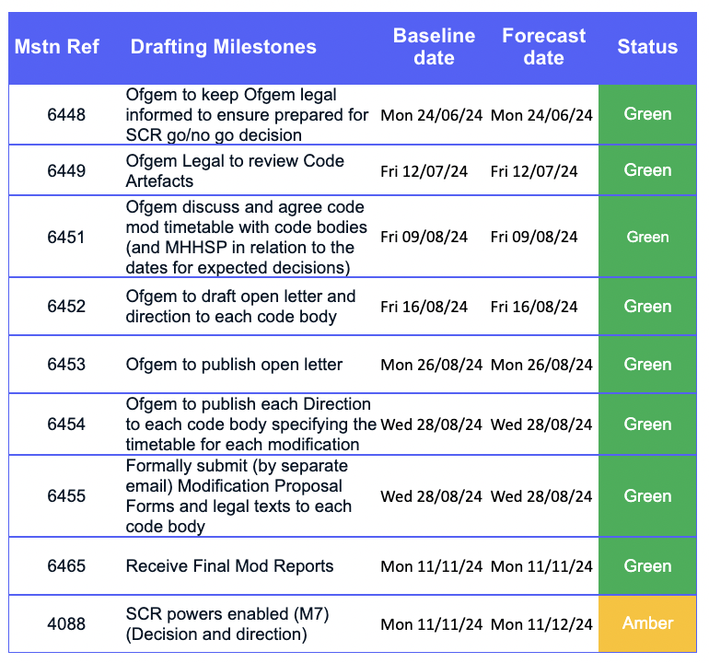

Description of change:
(what is the change you are proposing)

It is proposed that the M7 milestone delivery date is amended from 11 November 2024 to 11 December 2024.

Ofgem has worked with the Programme to develop a revised M7 Delivery Plan based on moving the M7 milestone and revising the milestone title and description to provide clarity on what is being delivered by that date.

Ofgem proposes that the title of M7 changes to “Ofgem decisions on M6 baselined code modification proposals”.

Ofgem also proposes a new description of “Ofgem makes decisions and directions in relation to the Authority-led SCR code modification proposals baselined by the Programme at M6”.

Ofgem has also worked with relevant Code Bodies on the timetable for consulting and reporting on the M6 baselined modification proposals. The table below reflects those discussions and indicates the timeframe that Ofgem expects to follow upon receipt of the final reports from the code bodies.
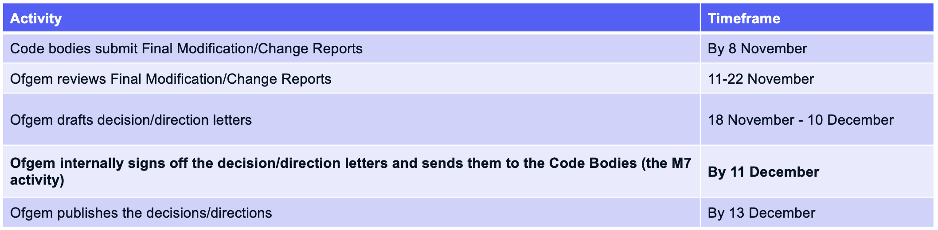
On a point of detail, please note that Ofgem no longer intends to draft and publish the open letter currently referred to in rows 6452 and 6453 of the plan. It is therefore proposed to delete these references from the plan.
Justification for change:
(please attach any evidence to support your justification)

M7 is currently at risk, and the milestone title and description are not representative of the activities to be completed.
Ofgem was originally intending to issue an open letter to industry after the CCAG baselines the code text in August. The letter was to have flagged that Ofgem would shortly be raising proposals to modify the Balancing and Settlement Code (BSC), Retail Energy Code (REC) and Distribution Connection and Use of System Agreement (DCUSA) to introduce the MHHS arrangements. Ofgem now expects that the Programme will, after the CCAG meeting in August, publish a Headline Report for Programme Participants outlining any decision that CCAG has taken to baseline the code change proposal and identifying next steps, including setting out the expectation that Ofgem will raise modifications to the BSC, REC and DCUSA in early September. Given this, Ofgem considers it unnecessary to draft and publish a separate open letter covering much the same ground.
Consequences of no change:
(what is the consequence of no change)

If we do not change the M7 deadline, it will be missed. Also, if we do not change the milestone title and description, these will remain inaccurate and misleading. Remedying the description will increase clarity and certainty for industry about what is being delivered at M7.

Alternative options:
(What alternative options or mitigations that have been considered)

The alternative is to do nothing and to ‘crash-through’ the milestone date. However, this is not good practice for programme governance. It is better to propose changes to the milestone, explain why they are necessary and seek industry support for them.
Risks associated with potential change:
(what risks related to implementation of the proposed change have been identified)

As per R444, there is a risk that the SCR consultation process highlights issues requiring resolution in the Programme. The proposal mitigates this risk by giving Ofgem and industry appropriate timescales to address any issues that arise.
Stakeholders consulted on the potential change:
(Please document the stakeholders, or stakeholder groups that have been consulted to date on this change. The Change Raiser should consult with relevant programme parties in the drafting of the request, prior to submission to PMO).

At the CCAG meeting on May 22, Ofgem set out and explained its intention to raise a change to the M7 milestone deadline, title and description. The CCAG, which owns the Code Drafting plan, raised no objections with this approach. Consequently, Ofgem is raising this Change Request.

Target date by which a decision is required: | August PSG

Part B – Initial Impact of proposed change
Guidance – This section should be completed by the Change Raiser before being submitted to the MHHS PMO.
Please document the benefits of the change and to delivery of the programme objectives

What benefits does the change bring
(list the benefits of the change and how this improves the business case)

The proposal gives Ofgem sufficient time to review the final modification reports submitted by the BSC, REC and DCUSA Panels, to engage as necessary with stakeholders in relation to any issues raised during the consultation, and to draft and secure internal approvals for the decisions being made. This additional time will ensure that those decisions are robust and in the interests of consumers.

Programme Objective | Benefit to delivery of the programme objective
To deliver the Design Working Group’s Target Operating Model (TOM) covering the ‘Meter to Bank’ process for all Supplier Volume Allocation Settlement meters | N/A
To deliver services to support the revised Settlement Timetable in line with the Design Working Group’s recommendation | N/A
To implement all related Code changes identified under Ofgem’s Significant Code Review (SCR) | As noted above, the proposal ensures that Ofgem will have sufficient time to consider any material issues raised in response to the consultation on the Authority led code modification proposals. This will ensure that subsequent decisions are taken in the light of all relevant information.
To implement MHHS in accordance with the MHHS Implementation Timetable | N/A
To deliver programme capabilities and outcomes to enable the realisation of benefits in compliance with Ofgem’s Full Business Case | N/A
To prove and provide a model for future such industry-led change programmes | N/A

Guidance – Please document the known programme parties and programme deliverables that may be impacted by the proposed change

Impacted areas | Impacted items
Impacted Parties | There is an impact to the Code Bodies (as regards the BSCCo, RECCo and DCUSA) that the period during their processing of Code Artefacts in preparation for M8 is extended by 1 month.
Impacted Deliverables | The Ofgem M7 decision and direction will be delayed by up to 1 month.
Impacted Milestones | M7

Note – Please refer to MHHS DEL174 Change Request Guidance for Programme Participants for information on how to score the initial assessment.

Initial assessment
Necessity of change |  | Expected lead time
Rationale of change |  | Expected implementation window
Expected change impact

Guidance – Please include a reference and link to any additional documentation which the change relates to.
Change Request to be read in conjunction with:
Title | Reference

Part C.1 – Summary of Impact Assessment

Note – This section will be completed initially by the Change Raiser and then by Programme Participants as part of the full Impact Assessment.

All Impact Assessment responses will be considered public and non-confidential unless otherwise marked. If there are any specific elements of the response (e.g. costs) that are confidential, please mark the specific sections as confidential rather than the response as a whole. The MHHS Programme will publish all Impact Assessment responses and redact any confidential information as noted.
Guidance – Programme Participants are required to:
- Respond with ‘Agree’, ‘Disagree’ or ‘Abstain’, deleting as appropriate. If the respondent agrees, they can provide additional evidence to further support the assessment. If the respondent disagrees or abstains, they should provide a detailed rationale as to why.

- Add any additional effects that have not already been identified. In doing so, they should provide as much detail as possible to allow a robust assessment to be made.

- Proceed to Part C.2 for Impact Assessment Recommendation response once completed.

Part C.1 – Summary of Impact Assessment (complete as appropriate)
Effect on benefits
N/A

<Delete as appropriate>: Agree Disagree Abstain
Impact Assessment respondents to add supporting commentary to support their selection. Where possible, Impact Assessment respondents to identify and describe any further impacts.
Impact Assessment respondents should consider and provide detail of any additional effect e.g. whether there will be an impact on when a benefit will be realised; who will realise the benefit; the extent to which the benefit will be realised.
Where possible, contextual information should be included e.g. the benefit will be delayed by X weeks; the change means Y population will also realise the benefit.
Effect on consumers
N/A

<Delete as appropriate>: Agree Disagree Abstain
Impact Assessment respondents to add supporting commentary to support their selection. Where possible, Impact Assessment respondents to identify and describe any further impacts.
Impact Assessment respondents should consider and provide detail of any additional effect e.g. whether there will be an impact on service delivery to consumers; will there be a cost impact to consumers; will there be a choice impact to consumers?
Where possible, contextual information should be included e.g. what is the scale of the effect? Will the effect be permanent?
Effect on schedule
This change will provide clarity and certainty about what is being delivered at M7 and will ensure that Ofgem has enough time to make a robust, fully informed decision without impacting other deliverables or milestones.
<Delete as appropriate>: Agree Disagree Abstain
Impact Assessment respondents to add supporting commentary to support their selection. Where possible, Impact Assessment respondents to identify and describe any further impacts.
Impact Assessment respondents should consider and provide detail of any additional effect e.g. will the schedule/milestones be directly impacted; will the schedule/milestones be indirectly impacted.
Where possible, contextual information should be included e.g. the change will delay the project by X days; the change will require additional resource to complete (though detail resource in resource section); the delay can/cannot be recovered by condensing Y activity.
Effect on costs
No impacts on costs identified

<Delete as appropriate>: Agree Disagree Abstain
Impact Assessment respondents to add supporting commentary to support their selection. Where possible, Impact Assessment respondents to identify and describe any further impacts.
Impact Assessment respondents should consider and provide detail of any additional effect e.g. will the change cause a loss of income; will the change cause additional cost; will the change cause a reprofiling of cost?
Where possible, contextual information should be included e.g. whether it is capital or operating expenditure that will be affected; what period costs will be affected in; what the rough order of magnitude of the cost impact will be and if organisation will be able to absorb it?
Effect on resources
No impacts on resources identified

<Delete as appropriate>: Agree Disagree Abstain
Impact Assessment respondents to add supporting commentary to support their selection. Where possible, Impact Assessment respondents to identify and describe any further impacts.
Impact Assessment respondents should consider and provide detail of any additional effect e.g. will there be an impact on tools or equipment; will there be an impact on staff capacity; will there be an impact on staff skills or capability?
Where possible, contextual information should be included e.g. the change will require X additional staff for Y period of time; the change requires Z training or support.
Effect on contract
No impacts on contract identified

<Delete as appropriate>: Agree Disagree Abstain
Impact Assessment respondents to add supporting commentary to support their selection. Where possible, Impact Assessment respondents to identify and describe any further impacts.
Impact Assessment respondents should consider and provide detail of any additional effect e.g. whether there will be an impact on contracts with sub-contractors; whether there will be an impact on contracts with vendors; whether there will be an impact on contracts with regulators/ESO.
Where possible, contextual information should be included e.g. the changes will require new contracts to be created; the changes will variations to existing contracts; the changes will affect ability to meet contract requirements.
Risks
There is a small risk of a delay to M8 because Code Bodies will not have certainty on the final text until later in the year, meaning they could be working on artefacts which get changed. Code Bodies have confirmed they are starting on their M8 activities in August and should be able to manage any final changes in the months after M7 delivery, without impacting M8 delivery.

<Delete as appropriate>: Agree Disagree Abstain
Impact Assessment respondents to add supporting commentary to support their selection. Where possible, Impact Assessment respondents to identify and describe any further impacts.
Impact Assessment respondents should consider and provide detail of any additional effect e.g. will existing risks be affected; will new risks be created?
Where possible, contextual information should be included e.g. the change will affect the likelihood of a risk occurring, the change will affect the impact the risk would have, the change will require additional controls and mitigation.

Part C.2 – Impact Assessment Recommendation

Note – This section must be completed initially by the Change Raiser and then by Programme Participants as part of the full Impact Assessment.
Guidance – The primary reporting metric of the Impact Assessment is the recommendation response. The consolidated response will be presented to the relevant governance group(s) and decision maker(s) with the totals for ‘Agree’, ‘Disagree’ or ‘Abstain’. As such, please ensure this section is completed before the form is returned to MHHS PMO. Provide detailed rationale and evidence in the commentary field.

Part C.2 – Impact Assessment Recommendation (mandatory)
Recommendation
It is recommended by the Change Raiser that the change is approved.
<Delete as appropriate>: Agree Disagree Abstain
Impact Assessment respondents to add supporting commentary to support their selection.

Impact assessment done by: <Name>

Guidance: If you are a third party responding on behalf of another Programme Participant, please state this in your response.

Impact assessment completed on behalf of: <Name>

Part D – Change approval and decision
Guidance: The approvals section will be completed by the MHHS PMO once the Impact Assessment has been reviewed.

Part D - Approvals
Decision authority level
<Based on the impact assessment, state who is required to make a decision concerning this change>

Guidance - This section will be completed by the MHHS PMO and Change Owner following the review of the impact assessment and decision reached by the SRO.

Part D – Change decision
Decision: |  | Date
Approvers:
Change Owner:
Action:
Changed Items | Pre-change version |  | Revised version

Part E – Implementation completion
Guidance - This section will be completed by the MHHS PMO at the end of the post-implementation process.

Part E – Implementation completion
Comment |  | Date

Guidance – The Closure Checklist in MHHS DEL175 Change Log must also be completed by MHHS PMO at this stage.

Checklist Completed | Completed by
Yes/No

Guidance – This section will be completed by the MHHS PMO at the end of the post-implementation process and should be used to add any appropriate references of the change once it has been completed.

References
Ref | Document number | Description

